MOMENT OF INERTIA

Topics Covered

• Finding moment of inertia analytically and experimentally.

Prerequisites

• Hardware Interfacing laboratory experiment
1 Background

The freebody diagram of the QUBEServo 2 pendulum system is shown in Figure 1.1.

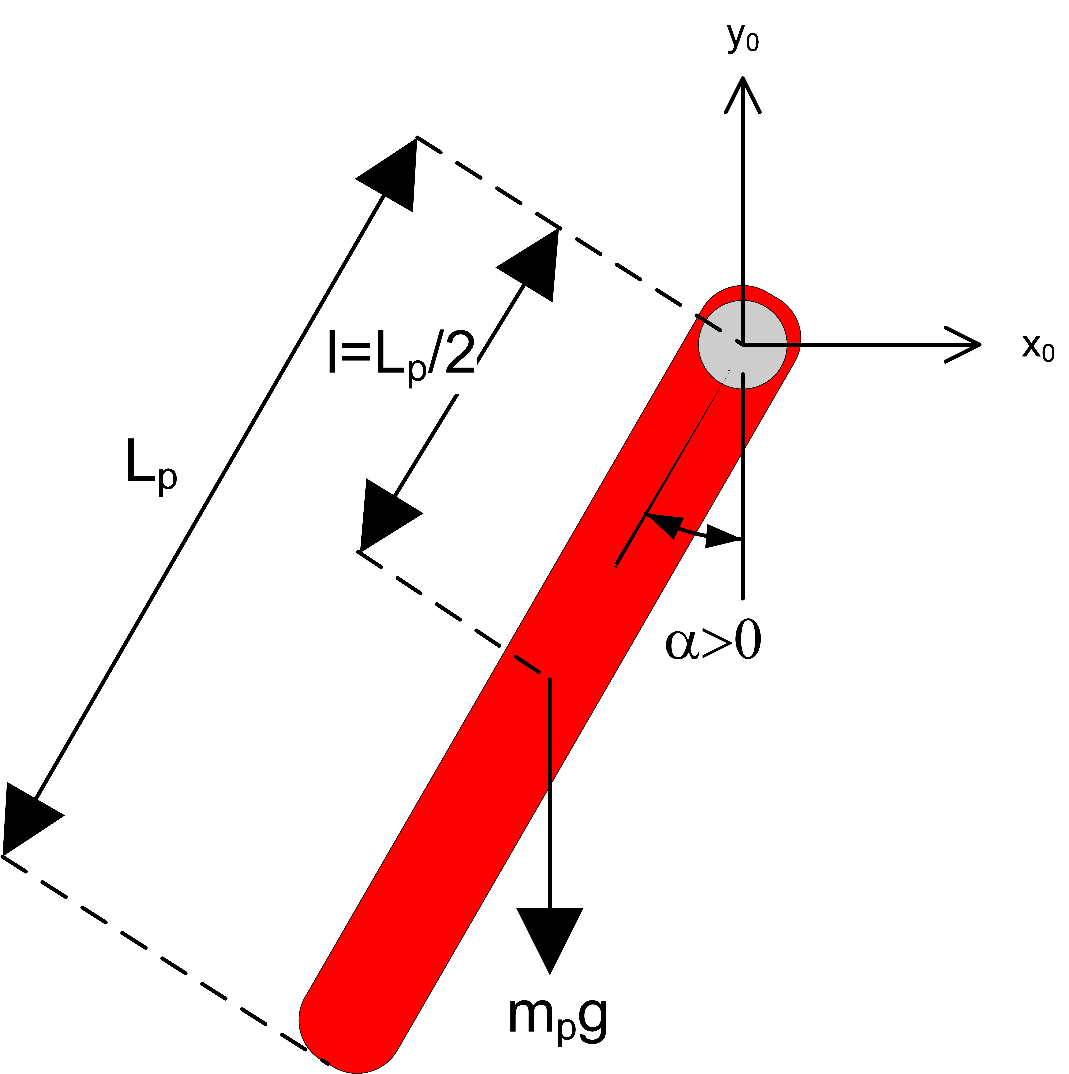

Figure 1.1: Freebody diagram of pendulum

From the freebody diagram in Figure 1.1, the resulting nonlinear equation of motion of the pendulum is

Jp α¨(t) = mp gl sin (α(t)), (1.1)

where Jp is the moment of inertia of the pendulum at the pivot axis, mp is the mass of the pendulum, Lp is the length of the pendulum (from pivot to end), and l = Lp /2 is the distance between the pivot and center of mass.

The moment of inertia of the pendulum can be found experimentally. Assuming the pendulum is not actuated, linearizing Equation 1.1 and solving for the differential equation yields

J = mp gl , (1.2)
p (2πf )2

where f is the measured frequency of the pendulum as the arm remains rigid. The frequency is calculated using

ncyc
f = (1.3)
∆t

where ncyc is the number of cycles and ∆t is the duration of these cycles. Alternatively, Jp can be calculated using the moment of inertia expression
∫
J = r2 dm, (1.4)

where r is the perpendicular distance between the element mass dm and the axis of rotation.
2 In-Lab Exercises

Based on the model already designed in Hardware Interfacing laboratory experiment, design a model that measures the pendulum angle using the encoder as shown in Figure 2.1.

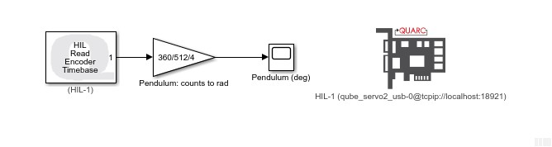

Figure 2.1: Displays measured pendulum angle

1. Find the moment of inertia acting about the pendulum pivot using the freebody diagram. Make sure you evaluate it numerically using the parameters defined in the QUBEServo 2 User Manual.
Hint: For solid objects with a uniform density, you can express the differential mass in terms of differential length.

2. Use the supplied SIMULINK@ model shown in Figure 2.1 or design your own. Enter 360/(512 ∗ 4) in the encoder sensor gain to measure the pendulum angle in degrees.

3. Run the QLABS@ software.

4. Load the QUBEServo 2 Pendulum Virtual Experiment by going to QUBE 2 Pendulum | Pendulum Workspace
virtual system.

5. In QLABS@ , click on the Options button.

6. Turn ON the Lock servo base option and set Pendulum lift angle (deg) to 10 degrees. This will hold the rotary arm in place and allow you to bring the pendulum up to the 10 degree mark.

7. Run the Simulink model. With the model running, manually bring up the pendulum to the 10 degrees by clicking on the Lift pendulum button in QLABS@ . The scope response should be similar to Figure 2.2.

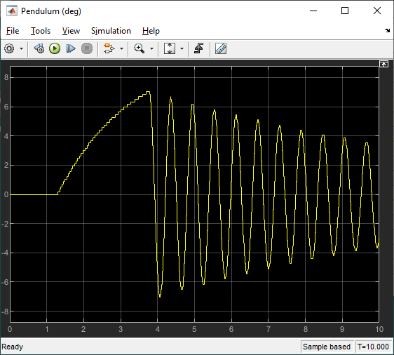

Figure 2.2: Freeoscillation response of pendulum
8. Find the frequency and moment of inertia of the pendulum using the observed results.

9. Compare the moment of inertia calculated analytically in Exercise 1 and the moment of inertia found experimentally. Is there a large discrepancy between them?

© 2021 Quanser Inc., All rights reserved.

Quanser Inc.
119 Spy Court Markham, Ontario L3R 5H6
Canada info@quanser.com Phone: 19059403575
Fax: 19059403576

Printed in Markham, Ontario.

For more information on the solutions Quanser Inc. offers, please visit the web site at:
http://www.quanser.com

This document and the software described in it are provided subject to a license agreement. Neither the software nor this document may be used or copied except as specified under the terms of that license agreement. Quanser Inc. grants the following rights: a) The right to reproduce the work, to incorporate the work into one or more collections, and to reproduce the work as incorporated in the collections, b) to create and reproduce adaptations provided reasonable steps are taken to clearly identify the changes that were made to the original work, c) to distribute and publically perform the work including as incorporated in collections, and d) to distribute and publicly perform adaptations. The above rights may be exercised in all media and formats whether now known or hereafter devised. These rights are granted subject to and limited by the following restrictions: a) You may not exercise any of the rights granted to You in above in any manner that is primarily intended for or directed toward commercial advantage or private monetary compensation, and b) You must keep intact all copyright notices for the Work and provide the name Quanser Inc. for attribution. These restrictions may not be waved without express prior written permission of Quanser Inc.

